Eden Park Primary School
Head Lice

An information leaflet about detecting and treating head lice

Facts About Head Lice
- Head lice are small, six-legged, wingless insects that live close to the scalp – not much bigger than a pin head.
- Head lice cannot fly, jump or swim.
- Head lice are common. Anyone can get head lice, but children are most affected because they often have close head-to-head contact.
- Head lice are not fussy about hair length or condition.
- ‘Nits’ are the empty white egg sacs from which lice have hatched out. Many people mistake the empty egg sacs or nits for head lice when they are actually evidence of a previous infestation of head lice. Only finding a live louse in the hair is evidence of an infestation.

Detection
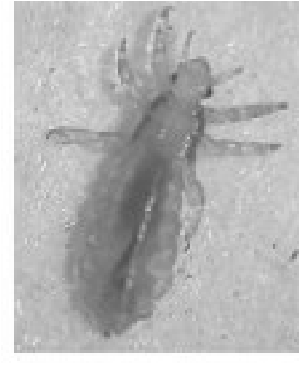
Head lice can’t be prevented but regular checking ensures early detection and treatment if necessary. The best detection method is wet combing (see back page) as head lice can easily be missed in dry hair. You should aim to check your children’s hair once a week during hair washing. You need your usual shampoo, ordinary conditioner and a louse detection comb. Remember that you are looking for living, moving head lice – the only evidence that your child has a head lice infestation. The comb must be fine enough and robust enough to catch the lice. Your pharmacist will be able to recommend a suitable one.
If you find any head lice, you should check all family members at the same time, and then begin treatment.

In School
It is impossible for a school to stay head lice free at all times. However, at Eden Park, we have several practices in place to help to reduce the number of cases:
- We send out information about detection and treatment to all parents every year. This is also available on our website.
- If staff see live lice in a child’s hair, we will contact the parents or carers to let them know.
- We ask parents to let their child’s class teacher know if they have live lice, so that classes with several cases within a short period of time can be resent the information leaflet and a fine-toothed comb.

Treatment

There are three treatment options. One is to use insecticide lotion, another is silicone oil (such as dimeticone) and the third is removal by wet combing. Here are some details about the different options:

Lotions and silicone oils
Lotions and silicone oils can be bought over the counter at your local pharmacy. You can ask your health visitor, pharmacist or doctor about which lotion or silicone oil is most effective.
Note the following advice for using lotions or silicone oils:

- Do not use lotions or silicone oils unless you find a living, moving louse.
- Although the lotion will kill the lice, it will not kill the eggs. You will need to apply the lotion again after seven days to kill any newly hatched baby lice. With silicone oils, the oils seem to work on the eggs but two applications are still recommended.
- You should not repeat the treatment at intervals of less than one week or apply it for more than three consecutive weeks as this will not increase its effectiveness.
- If live head lice are still being found after two different treatments, ask your doctor, pharmacist or health visitor for advice.
- Follow the instructions on the packet carefully. These will tell you how to apply the lotion or silicone oil, how long to leave it on the hair and when any repeat application is required for the treatment to be effective. The treatment method may vary between different lotions.
- People with asthma or allergies, pregnant or breastfeeding mothers, and parents or carers of very young children should always ask their doctor or pharmacist about which treatments are safe for them.
- Treatment does not prevent infestations, so should never be used unless a living, moving louse has been spotted.

Wet Combing
This is a non-insecticide alternative to lotions that involves combing out all lice with a fine-toothed detection comb using the wet combing method described below.

1. Shampoo the hair, apply lots of conditioner and use a wide-toothed comb to untangle and straighten.

2. Split the hair into sections and work on one section at a time. comb with the fine-toothed comb from root to end. pay particular attention to the back of the neck and the area around the ears.

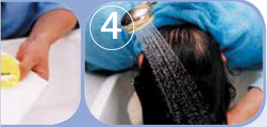
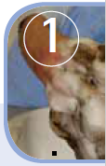
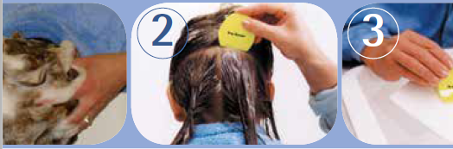
4. when the whole head of hair has been checked, rinse off the conditioner.

3. check the comb for live lice between each stroke by cleaning it on a tissue. remove any lice found.

To be effective, wet combing needs to be repeated every three days for up to three weeks to ensure that all head lice are removed.

Continue until you no longer find any lice for at least 2 treatments in a row.

